ABSTRACT

In this project, we implemented and evaluated classification algorithm for mining the data of four crucial human physical activities (walking, cycling, sitting, and lying) using five triaxial accelerometers worn concurrently on different parts of the body (dominant hip, upper arm, ankle, thigh, and wrist). The accelerometer data were collected, cleaned, and pre-processed to extract features from 10 s window.

These time and frequency domain features were used with Random Forest and k-Nearest Neighbour classifier to classify subject activities. The algorithms were evaluated based on Leave-One-Subject-Out (LOSO) and ten-fold cross-validation strategy using both accelerometer data as well as annotated activity labels from 33 participants in a lab.

Random Forest showed the best performance recognizing the activities with overall accuracy of 89 % for LOSO strategy for hip data. Combining data from both hip and ankle improved the overall accuracy by 3.5 %, and by 10% for lying activity, which had the lowest classification accuracy (80%) for hip data. We conclude that our algorithm that uses 10 features shows good activity classification, and is computationally efficient to be implemented in real-time mobile systems.

CHAPTER 1
INTRODUCTION

1.1 Introduction of the background:

Automatic detection of human physical activities (PA) data could have huge impacts not only in health interventions, social networking, lifestyle, but also in targeted advertisement and corporate management. Accelerometers can be used in collecting motion detectors data as well as for body-position data and posture sensing data collection. Their low power consumption, small dimensions, and light weight make them great candidates to make long-term activity monitoring, balance assessment, fall detection more practical. The. A multisite configuration is preferable to detect variety of activities with fine complexity by capturing upper and lower body motion independently. Hip location has been studied extensively in activity recognition data as it generally captures major body motion.

In this project, we implemented classification algorithms for previously collected lab-setting accelerometer data from 33 participants performing a set of activities. We aimed at classifying activities for four classes (walking, cycling, sitting, and lying), using a LOSO and ten-fold strategy to evaluate algorithm performance. From a 10 sec window, we extracted some of the most common features in activity classification based on accelerometer data.

CHAPTER 2
RELATED WORK

Sensor-based Activity recognition (AR) Data is an emerging field of research that has made significant progress in recent, and has attracted multiple domains data mining applications & research work. There is no published literature validating the efficacy and accuracy of these systems for AR collected data. Therefore, it is imperative to work on validating data mining algorithms and determine the optimum sensor placement site or a combination of sites for robust recognition of everyday human activities.

The data collected by physical activities that we focused on were walking, cycling, lying on back, and sitting. The rationale for picking these activities was that two of them are stationary and the other two mobile.

A real-time activity recognition system could reward the user after detecting mobile activities (walking and cycling), or give reinforcement feedback in case detecting long duration stationary activities (sitting and lying on back). Wocket accelerometer was used to collect the data.

Wockets were used because they are sufficiently small that they can be comfortably worn on all five body locations at the same time. We place wearable sensors at five different positions: dominant ankle, dominant thigh, dominant hip, dominant arm and dominant wrist. These placement sites were selected because of their relevance in exercise monitoring research.

2.1 Data mining tasks needed

The collected datasets consist of raw accelerometer data from 5 sensors placed in different body sites plus the annotated labels. The data mining techniques required for successful execution of the project involves:

- checking the quality and integrity of data, i.e.: if there is accelerometer data and/or annotation data missing

- checking if various data sources are coordinated/accordance with each other, and if the activity labels make sense with respective sensor data,

- removing of any outliers in terms of sensor data, annotations, or participant,

- performing dimensional reduction of sensor data (given high sampling rate of sensors),

- transforming data to relevant features for machine learning,

- determining best machine learning algorithm.

CHAPTER 3
PROPOSED METHOD

3.1 Data description and pre-processing

The dataset consists of several files per participant, among these files, we are only using six files. 5 files are the different output files from each sensor placed at different locations and 6th file is the annotation interval file. Basically, for each participant data we are using in these files:

● AnnotationIntervals.csv
● Wocket_00_RawCorrectedData_Dominant-Ankle.csv
● Wocket_01_RawCorrectedData_Dominant-Thigh.csv
● Wocket_02_RawCorrectedData_Dominant-Hip.csv
● Wocket_03_RawCorrectedData_Dominant-Wrist.csv
● Wocket_04_RawCorrectedData_Dominant-Upper-Arm.csv

The AnnotationIntervals.csv files has the time intervals and the activity annotations and the wocket files has the x,y,z acceleration along with the timestamp.

3.1.1 Data Pre-processing

For pre-processing, we extracted the above-mentioned files for each participant and created a merged file. This merged file was created on per participant basis. For merging, we took each wocket file with the timestamp and merged it with the annotation file by placing each time stamp into correct time interval.

In the annotation file we added 2 second to start-time and subtracted 2 second from end-time to avoid the transition phase between two activities. The transition phase was discarded to make the resultant data as unambiguous as possible in terms of its activity label. The final merged file had X,Y,Z, Sensor Location, Time-Stamp, Activity columns. This was performed for all 33 participants.

3.1.2 Formalization

The dataset consists of acceleration (unit: g or m/s2) in x, y and z direction with timestamps. It is also annotated with physical activity labels that account for all time points. These are the ground truth labels for this classification problem. We started by visualizing the raw data from all five placement sites for all four activities to observe the quality of the data and remove any outliers if present.

3.2 Methods Description
Once the data was pre-processed, and the merged file had been obtained for each participant as explained above, the relevant features were extracted from the dataset for classification purpose.

3.2.1 Feature Extraction

For feature extraction purpose, we considered 10 seconds window in each of the merged file, as 10 seconds is considered sufficient to detect any frequency features. For each of these windows, signal magnitude vector values (SM = √𝑎𝑐𝑐 𝑥2+𝑎𝑐𝑐 𝑦 2+𝑎𝑐𝑐 𝑧2) was calculated. This was done to remove the dependence of the resulting signal from the orientation of the sensor.

In addition to that, we performed the fast-Fourier transform (FFT) of the SM to obtain frequency related features that would explain intensity (from power) and pattern (from frequency) of each activity. A Butterworth band-pass filter was used to restrict frequencies within 0.3 - 15 Hz, the range relevant to normal human movement.

A smaller frequency (0.6 - 2.5 Hz) band was implemented based on table 1 that lists all the features we considered from both time and frequency domain features for a 10 second window. This calculation was done for each of the participant.

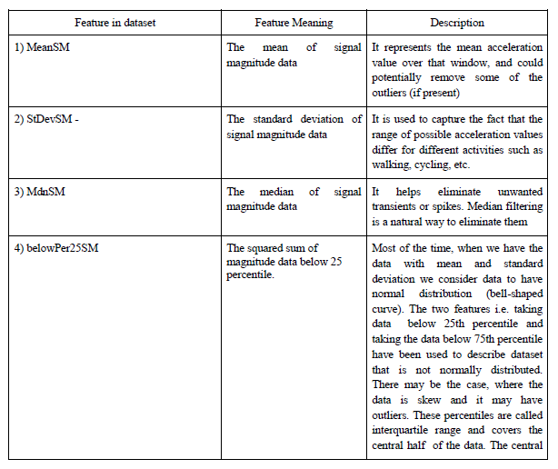
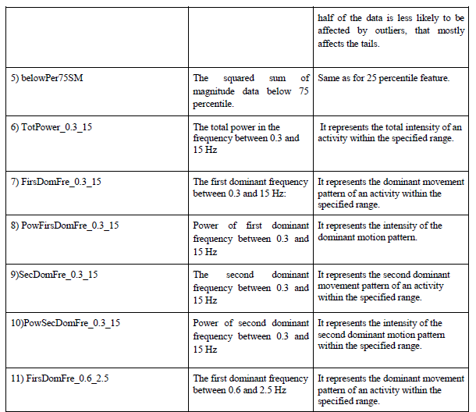
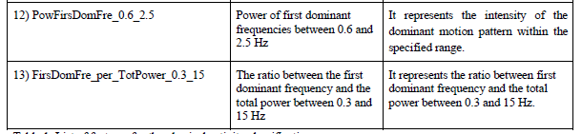

Table 1. List of features for the physical activity classification

3.2.2 Further processing

Univariate feature selection based on Analysis of Variance (ANOVA) was performed in training dataset during each cross-validation to select the most relevant features. This process ranks the features based on the difference in their means for each class/activity label. This process was able to discard three non-relevant features, namely: 25th and 75th percentile of SM and the ratio between the first dominant frequency and the total power between 0.3 and 15 Hz. The ten time-frequency domain feature set was further used to train and test the classification algorithm.

3.2.3 Classification approach and algorithm

For classification purpose, k-Nearest Neighbors (kNN) and Random Forests were employed. k-NN is a type of instance-based learning, or lazy learning, where the function is only approximated locally, and all computation is deferred until classification. The k-NN algorithm is among the simplest of all machine learning algorithms. K-Nearest Neighbor is a supervised learning algorithm where the result of new instance query is classified based on majority of K-Nearest Neighbor category. It is one of the most popular algorithms for pattern recognition. The best choice of k depends upon the data; generally, larger values of k reduce the effect of noise on the classification, but make boundaries between classes less distinct.

Various heuristic techniques can select a good k, for example, cross-validation. The training phase of the algorithm consists only of storing the feature vectors and class labels of the training samples. In the classification phase, k is a user-defined constant, and an un-labelled vector (a query or test point) is classified by assigning the label which is most frequent among the k training samples nearest to that query point.

Complexity of kNN: O(n) where n is the number of data points

3.2.4 Random Forests

Random forests are ensemble learning algorithms for classification that operate by constructing a multitude of decision trees at training time and outputting the class that is the mode of the classes. We choose Random Forests as they correct the overfitting common in individual decision trees. It achieves this by following a technique called bootstrap aggregating or bagging. Random Forests grows many classification trees. To classify a new object from an input vector, put the input vector down each of the trees in the forest. Each tree gives a classification, and we say the tree "votes" for that class. The forest chooses the classification having the most votes (over all the trees in the forest).

Some benefits of RF are
(i) It runs efficiently on large data bases
(ii) Generated forests can be saved for future use on other data
(iii) Random forests does not overfit
(iv) It is fast.

Complexity of Random Forest: If we have n instances and m attributes then computational cost of building tree is O(mn log n). If we grow M trees, then complexity is O(M(mn log n)).

We have used Grid Search technique to perform the exhaustive search over the parameters of Random Forest and k-NN. Grid Search accepts a range of parameters that will be used by the algorithm to fit the data. The parameters of the estimator used to apply these methods are optimized by cross-validated grid-search over a parameter grid.

Using this technique, we got following parameters for RF and k-NN:

● Random Forest:
○ Number of Decision Tree created: 50-200
○ Algorithm used: InfoGain(entropy)

● k-Nearest Neighbor:
○ Value of k varied from 9 - 11
○ Distance measure: euclidean
○ uniform weight for all the points

Python’s scikit-learn package is used for performing all of the above-mentioned tasks. This package provides standard machine learning libraries that we can modify as per our need and use it for our dataset. In addition to this, we will be using numpy, pandas for data processing and matplotlib for visualization purpose.

3.3 Additional Algorithm We Explored

We also explored One-Vs-Rest algorithm for multiclass classification. This algorithm involves training a single classifier per class, with the samples of that class as positive samples and all other samples as negative samples. This strategy requires the base classifiers to produce a real-valued confidence score for its decision, rather than just a class label; discrete class labels alone can lead to ambiguities, where multiple classes are predicted for a single sample.

One-Vs-Rest algorithm takes a binary classifier as a parameter. We tried SVM, Logistic Regression, and LDA as the binary classifiers. Out of which LDA gave the best accuracy but not as good as Random Forest and kNN algorithm. So, we focused on RF and kNN to build a robust classifier.

CHAPTER 4
EXPERIMENTAL RESULTS

4.1 Experiments design and Evaluation

4.1.1 Design
The Experiments for this project are designed in several stages.

● We started by visualizing the raw data i.e. the acceleration in x, y, z axes. This visualization helped us to see and analyse the acceleration patterns for different activities. Using this, we saw that how activity such as walking and climbing stairs have similar acceleration patterns and lying and sitting have similar acceleration patterns. This relation was expected.

● We pre-processed the dataset in several stages to achieve the required dataset. The pre-processing stages are shown in below.

4.1.2 Raw Data & Initial Pre-Processing
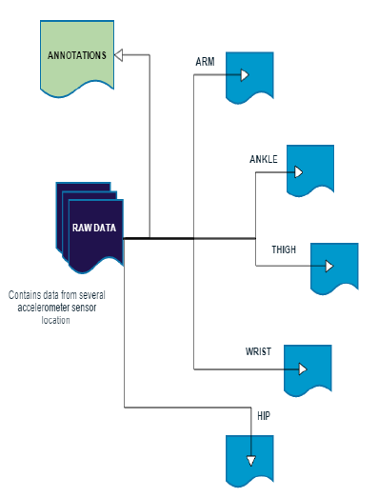
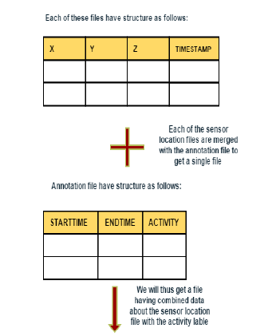
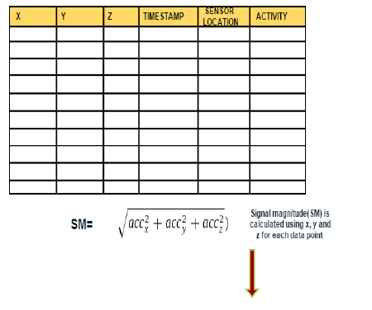
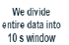

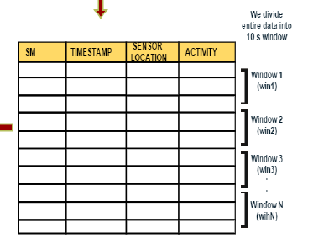
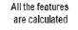
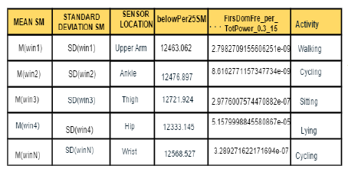

4.1.3 Pre-Processing For Extracting Feature Vector From Raw Data

Figure below shows the pre-processing resulting in final time-frequency domain features.
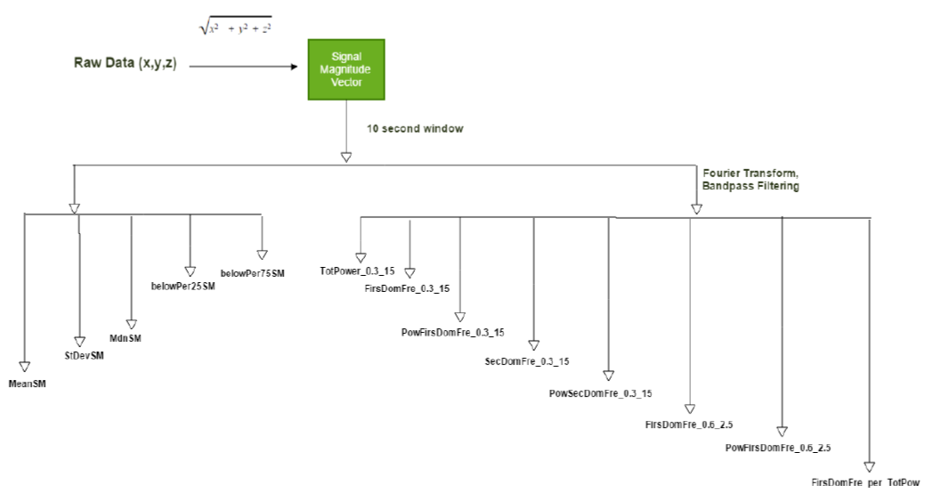
4.2 Evaluation

For evaluating our model, we use two validation techniques:

(i) The first approach is 10-fold cross validation technique. In this approach data (consisting of the windowed sections of data-label pairs) are randomized and divided into 10 different subsets (folds). The algorithm is trained on n-1 subsets and tested on the remaining one.

(ii) The second approach was leave-one-subject-out cross validation (LOSO validation). Recognition models were trained on data from all subjects except one that is used for the test phase.

In both case the procedure was repeated to test all data. The advantage of LOSO is that it simulates real-life situation when the model is trained in some number of subjects, but after deployed would be tested by individual user.

At the end of the procedure, results are shown using confusion matrices. Cross validation is a well-known established technique used for validating the model. The 10-fold cross validation technique may sometime overfit the data. The LOSO validation approach is more likely to avoid this problem and generalize to new data, it is therefore preferable method. Results will also be evaluated in terms of overall accuracy and F1-score for each class.

F1-score = 2 *(Precision*Recall/Precision +Recall) | where Precision = TP/TP+FP and Recall = TP/TP+FN.

True Positives (TP) are data correctly classified within the selected class. False Positives (FP) are those data that are incorrectly classified as belonging to the selected class. False Negatives (FN) are data belonging to the selected class that are incorrectly classified in another one. True Negative (TN) are data belonging to some class and predicted to some another class. The F1-score merges precision and recall into single number, it ranges from 0 to 1, where 1 is perfect classification.

The table summarizes the final results of the project that shows data from dominant hip and dominant ankle give best overall performance when used in RF classifier. The kNN underperforms and has slightly lower overall accuracy, while poorly classifying lying (just above chance).

We repeated LOSO by combining data from two sites (10 possible combinations from 5 sites), and not surprisingly, the combination of the top two sites (hip and ankle) that had given best overall performance individually, improved the overall accuracy by 3 %. The noteworthy thing about this was that the classification accuracy of lying (that has the lowest accuracy 80% for single site data classification) increased to 90%.

4.2 LOSO cross validation for kNN and Random Forest

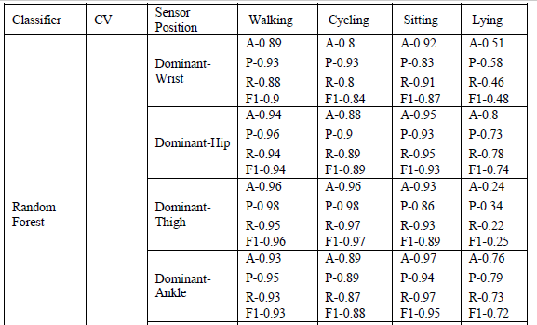
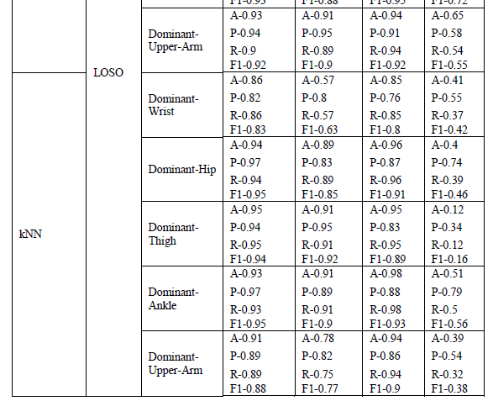

4.3 10-Fold cross validation for kNN and Random Forest

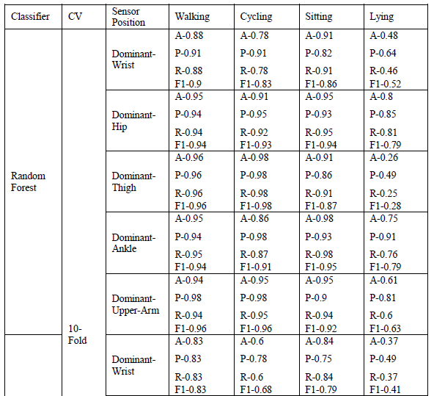
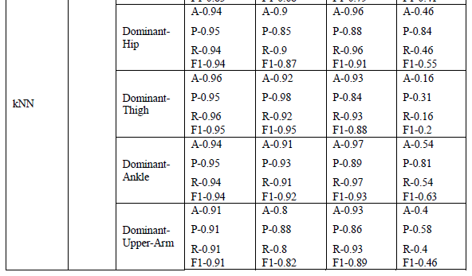

4.4 Outcome result for combination of Hip and Ankle data

Thus, we can see in the above table that combining data from Dominant-Hip and Dominant-Ankle improved overall outcome measures.

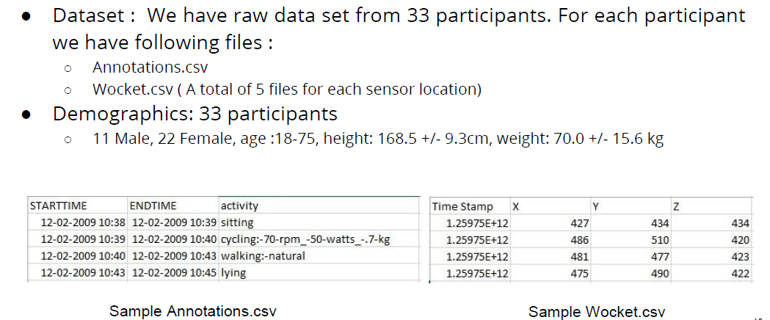

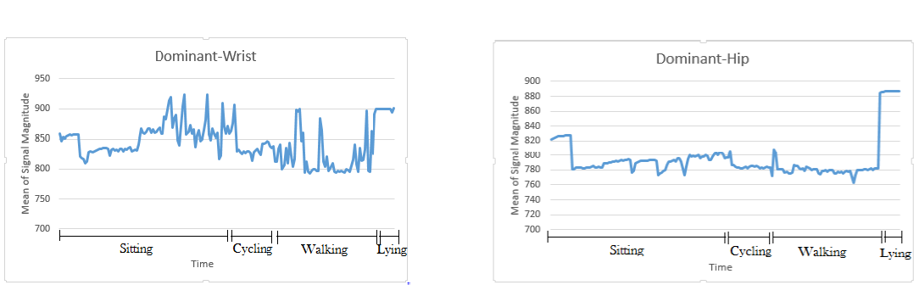

Fig. Mean Signal Magnitude for wrist (left) and hip (right) data
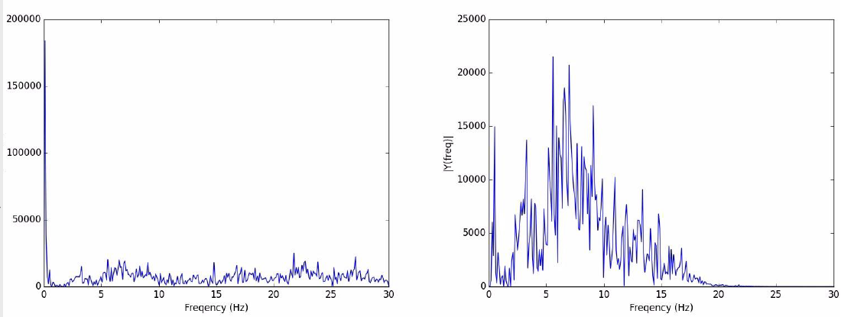

Fig. Frequency distribution before(left) and after(right) bandpass filtering

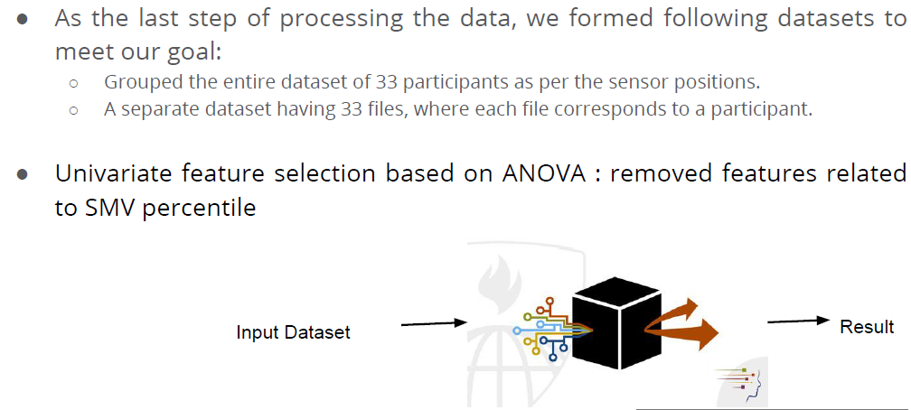

Confusion matrix after LOSO CV based on Dominant Wrist data
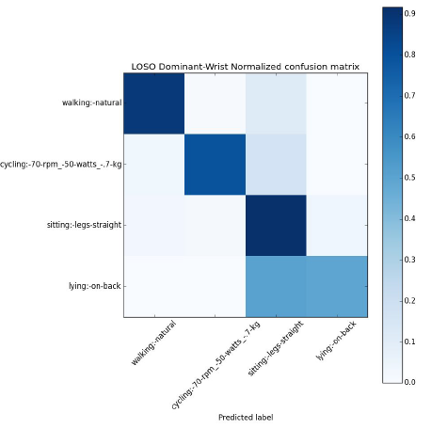

Random Forest

KNN
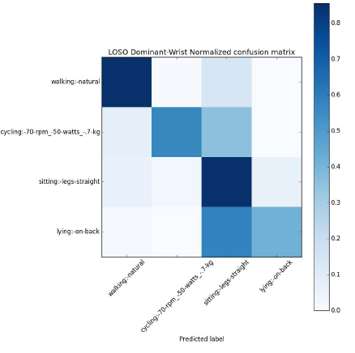
4.5 Confusion matrix after LOSO CV based on Dominant Upper Arm data

Random Forest
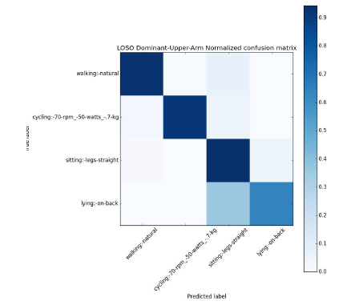

KNN
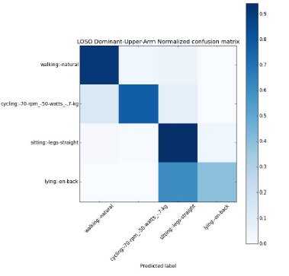

4.6 Confusion matrix after LOSO CV based on Dominant Thigh data

Random Forest
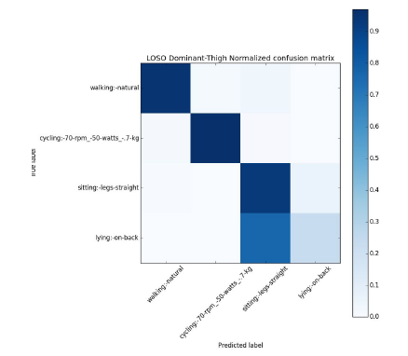

KNN
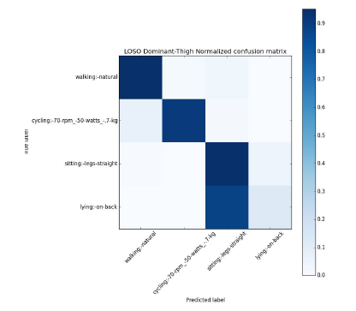

4.7 Confusion matrix after LOSO CV based on Dominant Ankle data

Random Forest

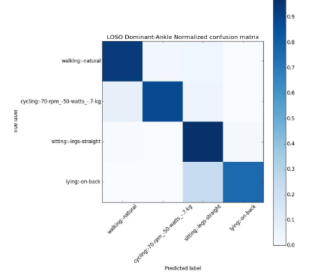

KNN
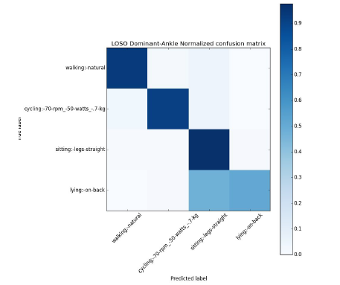

4.7 Confusion matrix after LOSO CV based on Dominant Hip data

Random Forest
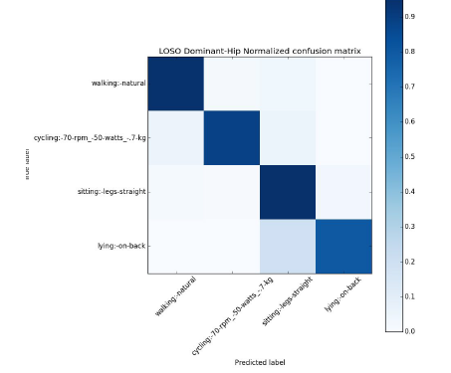

KNN
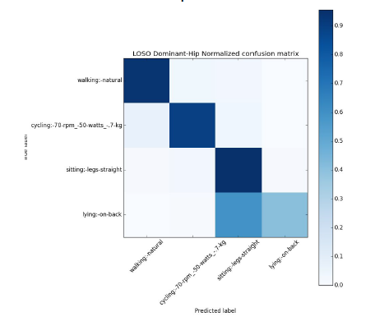

CHAPTER 5
CONCLUSION

We have identified the most suitable features required for classification of above mentioned activities: -
1. Mean,
2. St. deviation,
3. Median, along with
4. Frequency domain features extracted from signal magnitude vector.

Past experiments have proved that triaxial accelerometer data can be used to classify these types of human activities.

We performed LOSO and 10-fold cross validation techniques to validate our model using Random Forest and k-NN, and for both, RF works better than k-NN. We also found that sensor located at dominant hip position was most discriminative in classification, followed by sensor at dominant-ankle. Another task that was performed was to combine data from two sensors located at two different position and perform the LOSO and 10-fold CV.

This resulted in improved classification accuracy for some of the activities that were not classified as robustly using single site data. Future work could include including finer human activities in the classification, and implement the algorithm in real-time system like smart phone. Window size could also be decreased from 10 second to reduce the latency of such real-time system. The automatic detection of sensor placement sites could reduce the risk of people using wearable sensors inappropriately and inefficiently.

REFERENCES

1. Lockhart, J.W.; Pulickal, T.; Weiss, G.M. Applications of mobile activity recognition. Proceedings of the 14th ACM International Conference on Ubiquitous Computing, Pittsburgh, PA, USA, 5–8 September 2012; pp. 1054–1058

2. DeVaul, R.W., Dunn, S. Real-Time Motion Classification for Wearable Computing Applications. Technical report, MIT Media Laboratory (2001)

3. Foerster F. and Fahrenberg J. Motion pattern and posture: correctly assessed by calibrated accelerometers. In Behavior Research Methods, Instruments, & Computers, 32(3), 450-7. (2000) 15

4. Chen, L., Hoey, J., Nugent, C. D., Cook, D. J., and Yu, Z. Sensor-based activity recognition. IEEE Transaction on Systems, Man, and Cybernetics, Part C: Applications and Reviews PP, 99 (2012), 1 -19.

5. S.S. Intille, F. Albinali, S. Mota, B. Kuris, P. Botana, W.L. Haskell. Design of a wearable physical activity monitoring system using mobile phones and accelerometers, in: Proc. of the IEEE Engineering in Medicine and Biology Society Meeting, EMBS, Boston, Massachusetts USA, 2011.

6. Mannini A, Intille S S, Rosenberger M, Sabatini A M and Haskell W. Activity recognition using a single accelerometer placed at the wrist or ankle Med. Sci. Sports Exerc. 2013 45 2193–203

7. Tulen, J. H. M., Bussmann, J. B. J., van Steenis, H. G., Pepplinkhuizen, L., & Man in’t Veld, A. J. (1997). A novel tool to quantify physical activities: Ambulatory accelerometry in psychopharmacology. Journal of Clinical Psychopharmacology,17, 202–207.

8. Bao, L., Intille, S. Activity Recognition from User-Annotated Acceleration Data. In 2nd International Conference, PERVASIVE '04, Vienna, Austria, April 21-23, 2004.

9. Keller,J.M, Gray,M.R, Givens,J.A k-NearestNeighbor. IEEE Transactions on Systems Man and Cybernetics 07/1985; SMC-15(4). DOI: 10.1109/TSMC.1985.6313426

10. Ho, T.K. Random Decision Forests. Proceedings of the 3rd International Conference on Document Analysis and Recognition, Montreal, QC, 14–16 August 1995. pp. 278–282.
11. Baum, L. E., Petrie, T. Statistical Inference for Probabilistic Functions of Finite State Markov Chains. The Annals of Mathematical Statistics 37 (6): 1996. 1554–1563.

12. L. Breiman, J. Friedman, R. Olshen, and C. Stone. Classification and Regression Trees. Wadsworth International Group, 1984

13. L. Buitinck, G. Louppe, M. Blondel, F. Pedregosa, A. Müller, O. Grisel, V. Niculae, P. Prettenhofer, A. Gramfort, J. Grobler, R. Layton, J. Vanderplas, A. Joly, B. Holt, and G. Varoquaux. API design for machine learning software: experiences from the scikit-learn project. In ECML PKDD Workshop on Languages for Machine Learning, 2013.

14. Novel one-vs-rest classifier based on SVM and multi-spheres;Xu, L. / Zhao, G.-z. / Gu, H. in JOURNAL- ZHEJIANG UNIVERSITY ENGINEERING SCIENCE; 43, 2; 303-308; JOURNAL- ZHEJIANG UNIVERSITY ENGINEERING SCIENCE by ZHEJIANG UNIVERSITY PRESS; 2009

